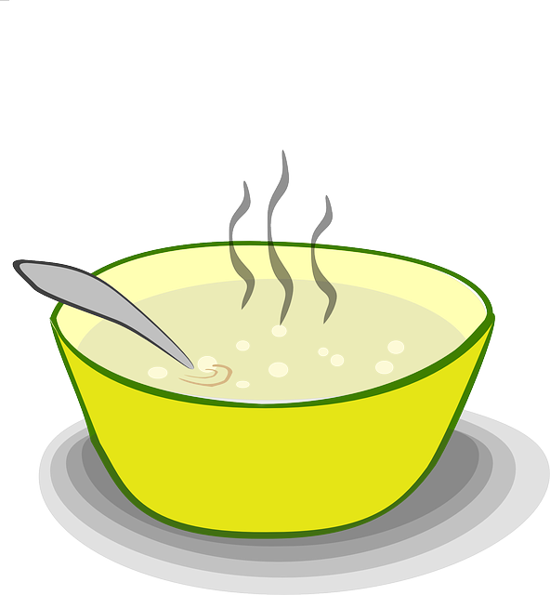

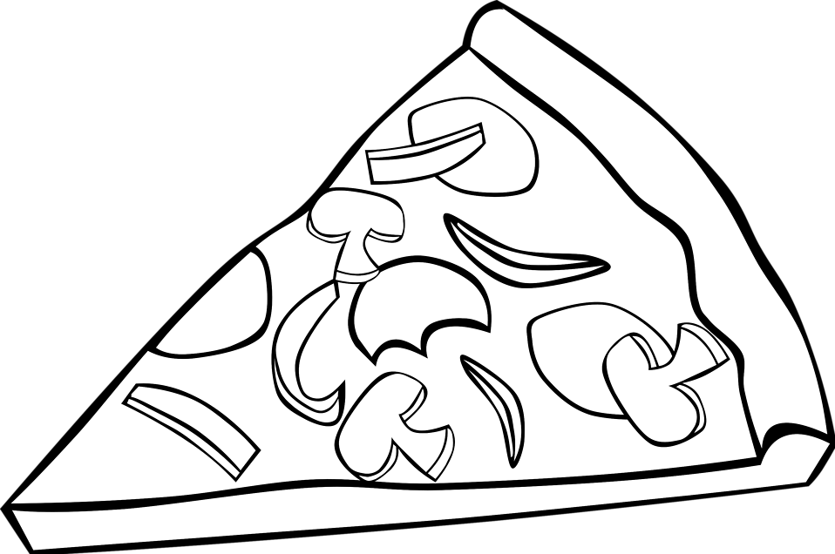
- Homework Menu: April 14 – 17, 2020
Spelling List
Homophones

Spelling Words
- to
- too
- two
- there
- their
- they’re
- where
- wear
- deer
- dear
Appetizer (2)
__ iReady Math: Complete at least 20 minutes of math iReady
___iReady Reading: Complete at least 20 minutes of reading iReady
___ Spelling City: Practice your spelling words at https://www.spellingcity.com/users/ctw1
___ Creative spelling: Practice your spelling words any way you want (chalk, paint, in the bathtub, type on the computer, etc.)
___Practice counting back starting from any number between 30 and 120.
Entree (2)
___Write sentences with each of your spelling words.
___Rhyming Words: Write each spelling word and a rhyming word next to it.
___ Practice writing your numbers from 100-150.
___ Write a story with all of your spelling words.


Dessert (2)
___ Play outside for 20 minutes.
___ Play a game to practice math skills.
___ Play a game to practice reading skills.
___ Show off your reading skills! Practice reading a book or poem. Then call someone and read it to them.

Daily Reading Response
Read a book with a grownup. Ask and answer a question about the beginning, middle, and end of the book. We are working on who, what, when, where, why questions. You do not need to write the questions and answers. Record the title of the book below.
Monday ________________________
Tuesday ________________________
Wednesday ________________________
Thursday
________________________

